Step 1: Importing Data into QGIS
- Start QGIS:
  - Open QGIS and create a new project.
- Add Shapefiles:
  - Method 1: Drag and drop each shapefile (e.g., tl_2024_36_tract.shp, NYC_Borough_Boundary.shp, nyc_parks.shp) directly into the QGIS Layers Panel.
  - Method 2:
    - Click on Layer > Add Layer > Add Vector Layer…
    - Browse to your file location, select the shapefile, and click Open.
  - Confirm that all three layers appear in your Layers Panel.

Step 2: Check and Harmonize Coordinate Reference Systems (CRS)
- Inspect CRS:
  - Right-click on each layer (e.g., NY State Census Tracts) and select Properties.
  - Under the Information (or Source) tab, check the CRS details.
- Reproject if Necessary:
  - If the layers are in different CRS, you should reproject them to a common CRS (a good choice is the CRS used by the NYC Borough Boundaries).
  - To reproject a layer:
    - Go to Reproject layer (you can use the Toolbox to find this as well or go to Processing > Toolbox and then search for “Reproject Layer”
    - Put the CRS reference system that you want (usually to match another CRS system)
  - Add the newly reprojected layer to your project if it doesn’t automatically appear.
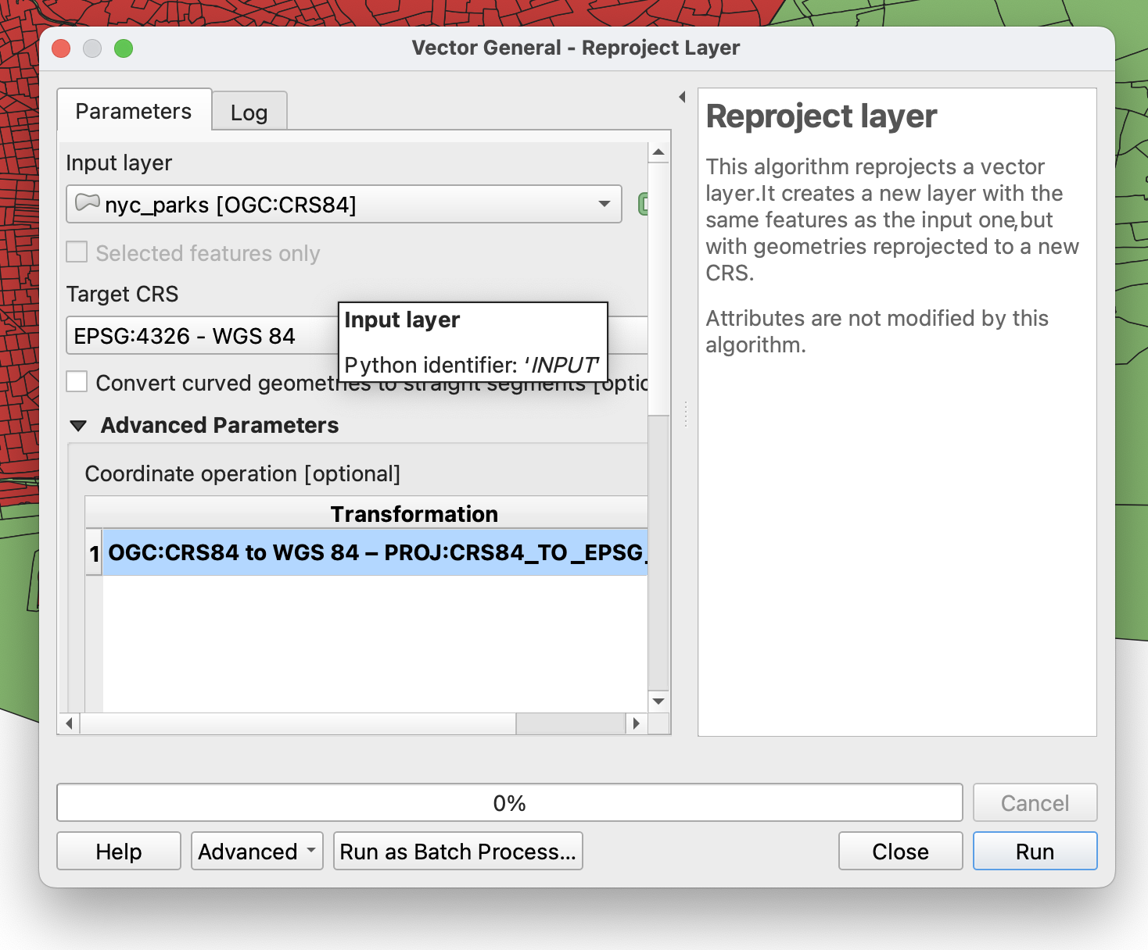

Step 3: Clipping Census Tracts to NYC Borough Boundaries
- Open the Clip Tool:
  - Go to Processing > Toolbox to open the Processing Toolbox.
  - In the toolbox, navigate to Vector overlay and double-click on Clip.
- Set Clip Parameters:
  - Input Layer: Select the NY State Census Tracts layer.
  - Overlay Layer: Select the NYC Borough Boundary layer.
  - Output Layer: Choose to save the result as a temporary layer or specify an output file path (e.g., nyc_census_tracts.shp).
- Run the Clip:
  - Click Run.
  - A new layer (e.g., “Clip”) will be added to your Layers Panel showing only the census tracts that fall within the NYC borough boundaries.
- Visual Check:
  - Toggle the layers’ visibility to confirm that the census tracts are now limited to the NYC area.
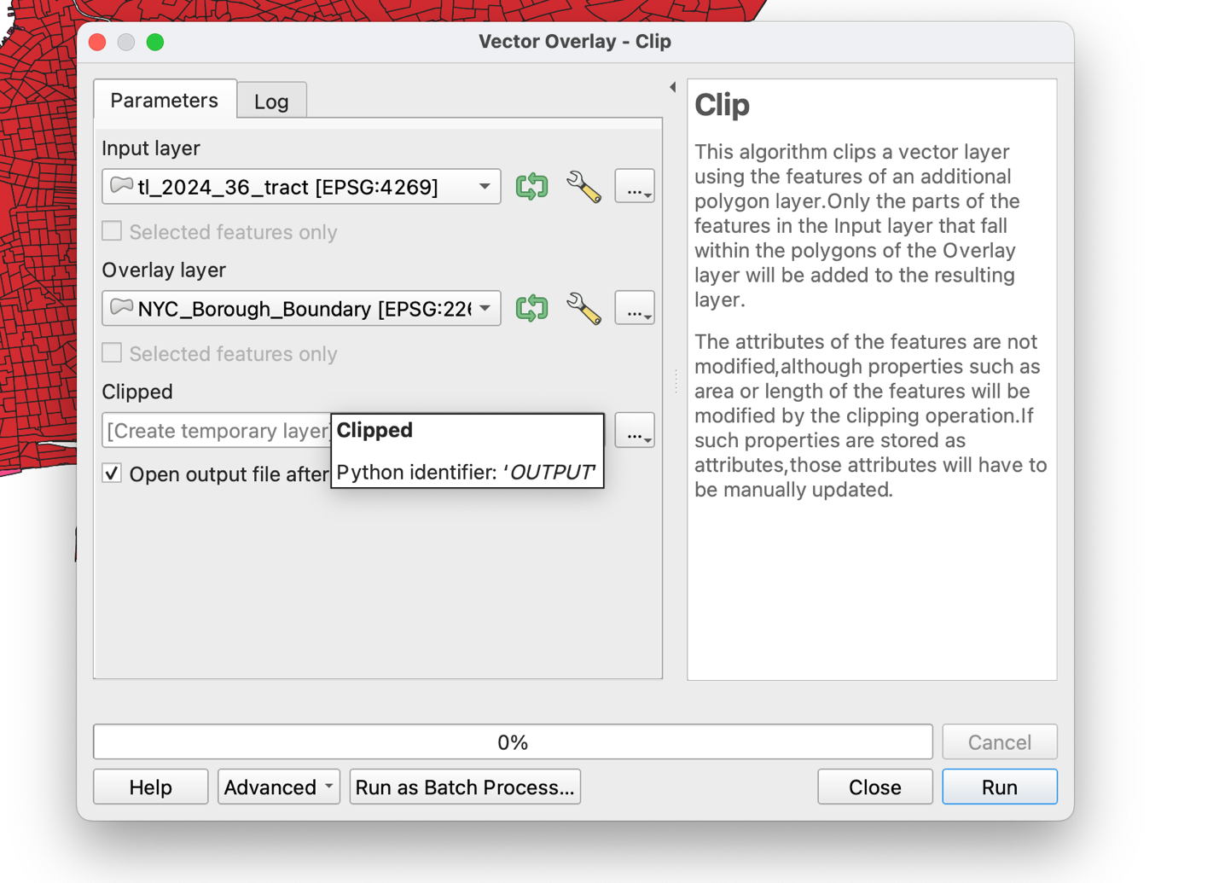
Step 4: Fix Geometries (if you skip this, there will be an error in Step 5)

The NYC Parks file has errors in the geometry that will stop us from merging it’s feature to the census tracts file. Thus we must fix the file geometry.
- Fix Geometries: Go to the Toolbox and search for “Fix Geomtries”
- Select Shapefile to Fix: Select Parks file and then Linework to fix this part of the geometry (the other option is structure which may need fixing but not in this case)
- Click Run

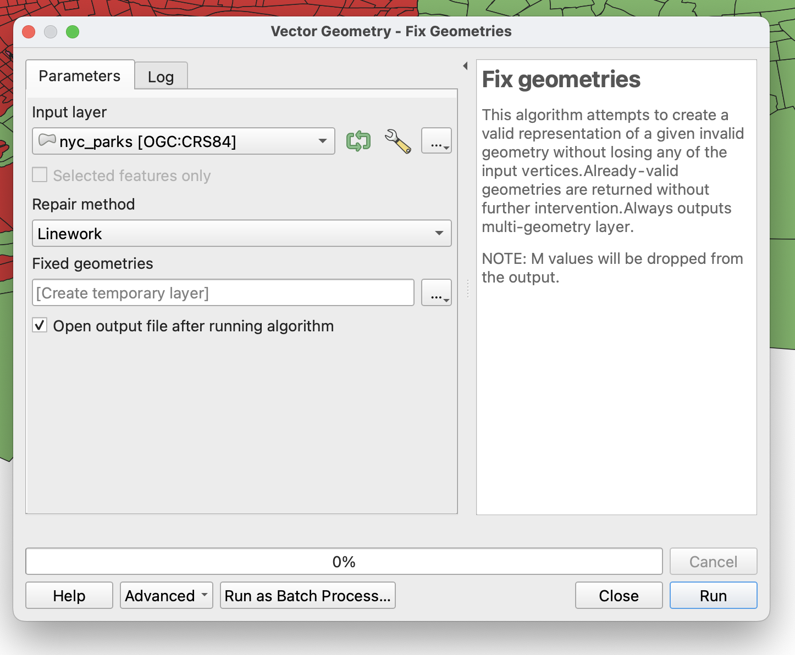

Step 5: Performing a Spatial Join with the Parks Shapefile
The goal is to attach census tract attributes to each park based on their spatial location.
- Open the Spatial Join Tool:
  - In the Processing Toolbox, search for Join attributes by location.
  - You might see two versions:
    - Join attributes by location (summary)
    - Join attributes by location
  - For a one-to-one join (each park gets the attributes of the tract it is within), select Join attributes by location.
- Set Join Parameters:
  - Target Vector Layer: Set this to the clipped NYC Census Tracts layer layer (the layer that will receive additional attributes).
  - Join Vector Layer: Set this to the Fixed Parks layer (the layer that contains the attributes to be joined).
  - Geometric Predicate: Choose within (this means the tool will join attributes to a park if it is within a census tract).
  - Fields to Copy: (Optional) You can select specific fields from the census tracts if you do not need all attributes.
  - Output Layer: Choose to save the joined result as a temporary layer or specify an output file (e.g., nyc_parks_joined.shp).
- Execute the Join:
  - Click Run.
  - A new layer will appear where each park feature now contains attributes from the census tract in which it falls.
- Verify the Join:
  - Right-click the new joined layer and select Open Attribute Table.
  - Scroll through to ensure that fields from the census tracts have been appended to the park records.

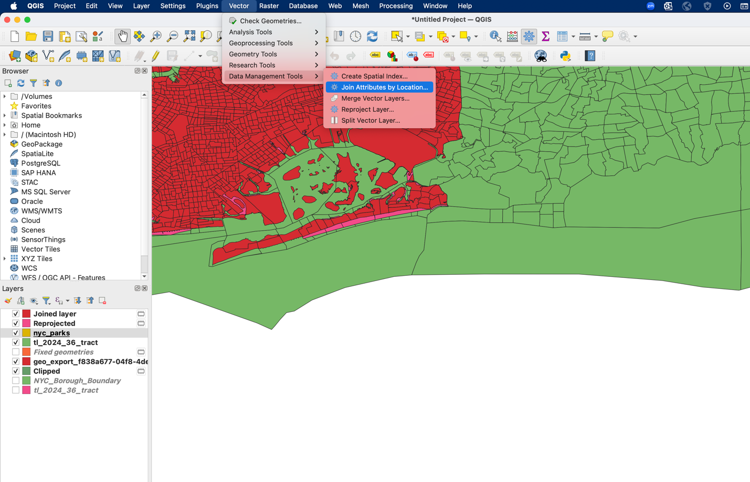

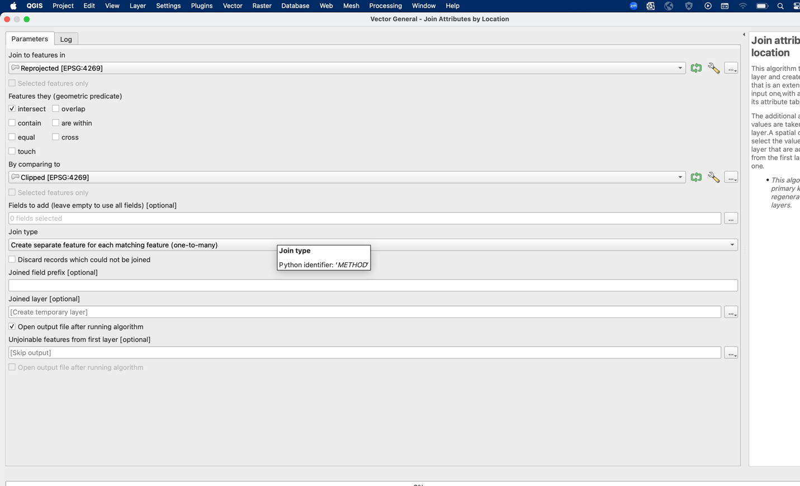

Step 7: Counts of Parks by Census Tracts
We will calculate the total numbers of parks within each census tract here.

7.1 Use “Join attributes by location (summary)”
- Open Processing Toolbox
- Search for: Join attributes by location (summary)

Set Parameters:
- Target Vector Layer:
→ Clipped NYC Census Tracts
- Join Vector Layer:
→ NYC Parks (fixed geometry version)
- Geometric Predicate:
→ intersects
- Fields to Summarize:
→ leave open
- Summaries to Calculate:
→ Select counts

Step 8: Summing Park Acres by Census Tract
We will calculate the total park acreage within each census tract as another method.

8.1 Use “Join attributes by location (summary)”
- Open Processing Toolbox
- Search for: Join attributes by location (summary)

Set Parameters:
- Target Vector Layer:
→ Clipped NYC Census Tracts
- Join Vector Layer:
→ NYC Parks (fixed geometry version)
- Geometric Predicate:
→ intersects
- Fields to Summarize:
→ Select acres
- Summaries to Calculate:
→ Select sum
- Output Layer:
Choose:
- Save to File…
Name it:
nyc_tracts_acres_sum.shp
Click Run.

Step 8.2: Export the Layer (If You Saved as Temporary)
If you accidentally saved as a temporary layer:
- Right-click the new layer in the Layers Panel.
- Select:
- Export → Save Features As…
- Choose format:
- ESRI Shapefile
- Name it:
- nyc_tracts_acres_sum.shp
- Click OK.

Step 9: Replace NULL Acres with Zero
Some tracts will show NULL if they contain no parks. We will convert those to 0.

9.1 Create a New Field
- Open the Attribute Table
- Click Field Calculator
- Create a new field:
  - Field Name:
  - acres_sum2
  - Type: Decimal Number (Real)
  - Precision: 2
Use this expression:
CASE WHEN "sum_acres" IS NULL THEN 0 ELSE "sum_acres" END
Click OK.

Step 9.2: Save Edits Permanently
- Click the Toggle Editing (pencil icon) to stop editing.
- Click Save Edits.
- Confirm changes.
If needed, right-click the layer and choose:
- Save

Step 10: Select Tracts with More Than One Park

10.1 Select the Features
- Open the Attribute Table of your census tract layer with nyc_parks_counts layer.
- Click Select by Expression.
- Use the following expression:
coalesce("count", 0) > 1 or “count” > 1
- Click Select Features.
- Close the Select by Expression window.
The selected tracts now represent census tracts with more than one park.

Step 10.2: Export Selected Features (IMPORTANT)
To permanently save this subset:
- Right-click the census tract layer in the Layers Panel.
- Select:
- Export → Save Selected Features As…
- In the Format dropdown, choose:
- ESRI Shapefile
- Click Browse and name the file:
- nyc_tracts_more_than_one_park.shp
- Click OK.

Step 11: Add NYC Borough Boundaries (Clean Frame)
- Right-click NYC Borough Boundary
- Click Properties → Symbology
- Click the symbol
Set:
- Fill Style → No Brush
- Stroke Color → Black
- Stroke Width → 0.8–1.0 mm
Click OK
Place borough layer above tracts in the Layers Panel.

Step 12: Map Tracts with >1 Park vs. 0 or 1 Park

12.1 Style the Full NYC Census Tract Clipped Layer (0 or 1 Park)
- Right-click the full census tract layer.
- Select Properties → Symbology.
- Keep Single Symbol selected.
- Click the symbol.
Set:
- Fill Color → Light Grey
Example: RGB 210, 210, 210
- Stroke Color → Light Grey or thin black
- Stroke Width → 0.2–0.4 mm
Click OK.
This layer will represent all tracts with none or one park.

12.2 Style the “More Than One Park” Layer
- Right-click:
- nyc_tracts_more_than_one_park.shp
- Select Properties → Symbology.
- Keep Single Symbol.
- Click the symbol.
Set:
- Fill Color → Green
Example: RGB 34, 139, 34
- Stroke Color → S
- lightly darker green or black
- Stroke Width → 0.4–0.6 mm
Click OK.

12.3 Alternative (Cleaner Two-Category Map)
If you want only two categories:
Create a new field called:
multi_park
Field Calculator expression:
CASE WHEN coalesce("count",0) > 1 THEN 'More than 1 park' WHEN coalesce("count",0) = 0 THEN 'No parks' ELSE 'One park' END
Then:
- Open Symbology
- Choose Categorized
- Value = multi_park
- Click Classify
- Set:
  - No parks → Grey
  - More than 1 park → Green
  - One park → Light neutral

Step 13: Create a Choropleth Map of Park Acreage (Natural Breaks)
We will map total park acreage per census tract using graduated symbology.

1)Open the Symbology Panel
- Right-click your census tract layer (the one containing acres_sum2).
- Select:
- Properties
- Click the Symbology tab.
- Change the renderer from:
- Single Symbol
to:
Graduated

2)Set the Choropleth Variable
- Value:
Select:
- acres_sum2
(Use acres_sum2, not sum_acres, so NULLs are already handled.)

3) Choose Classification Method
- Mode:
Select:
- Natural Breaks (Jenks)
- Classes:
Set to:
- 5
Natural Breaks groups tracts based on clusters in the data, minimizing within-class variance and maximizing between-class differences.

4) Select a Green Color Ramp
Click the Color Ramp dropdown and choose a green ramp.
Recommended:
- Light green → Dark green gradient
If needed:
- Click the ramp
- Choose Create New Color Ramp
- Select a gradient from:
  - Light green (low acres)
  - Dark green (high acres)

5) Classify the Data
Click:
Classify
You will now see five acreage ranges.

14. Lab Deliverables
You will submit two completed maps as PDF or high-resolution PNG files.
Both maps must include:
- Title
- Legend
- Borough boundaries
- Clear symbology
- Your name
- Date
- Data source (Census + NYC Parks)

Deliverable 1: Choropleth Map – Total Park Acreage

Map Requirements
Create a choropleth map showing:
Total park acreage per census tract (acres_sum2)

Symbology Requirements
- Renderer: Graduated
- Classification: Natural Breaks (Jenks)
- Number of Classes: 5
- Color Ramp: Green gradient
  - Light green = low acreage
  - Dark green = high acreage

Deliverable 2: Choropleth Map – Park-Rich vs. Park-Limited Tracts
Create a two-category map showing:
- Tracts with more than 1 park
- Tracts with 0 or 1 park
You may use:
- Two layers (recommended)
OR
- A categorized field (multi_park variable)

